Git and GitHub: how to save your work in a professional way

1. Introduction
Have you ever worked in a company or on a student project? If so, you may have already found yourself in my case with a file that looks like this:
.
└── big_project
├── big_project_01.xls
├── big_project_03.xls
├── big_project_final_féfé.xls
├── big_project_final.xls
├── big_project.xls
└── [WIP] big_project_fin.xls
Basically, it's often a mess in the world of code muggles. They spend their time creating thousands of files, just in case they need to revert to a previous version.
Now imagine having to work as a team on code folders containing thousands of files. Creating index_VERSIONNUMBER.html all over the place is clearly not the best solution. The ideal solution would be to have a software able to take pictures of a file at a given time, and to specify for each of these backups the answer to the following 4 questions:
- What: what files have been modified in this photograph?
- Who: who is responsible for this change?
- When: When was this change made?
- Why: why does this change exist?
With such software, no more stress and no more folders full of useless files! Good news: this kind of software exists and they are called "version control software". I like this diagram from GitTower which explains well what they are used for:
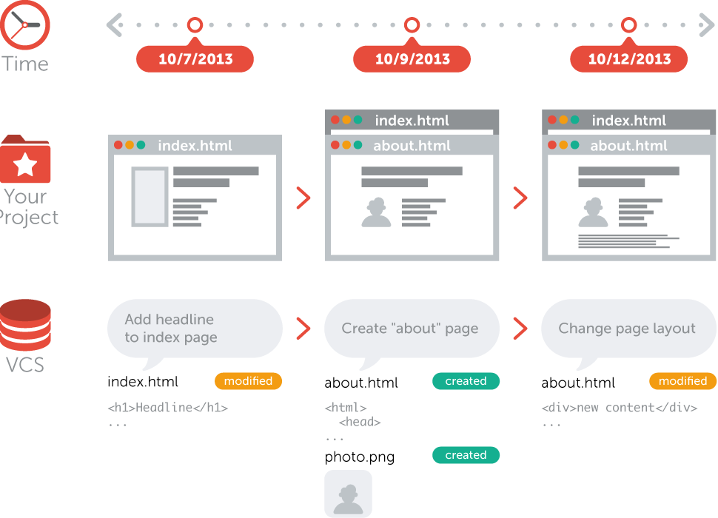

Do you understand now why the version manager called Git is a great software, and why it is a must-have in the code world? In this resource, we will see how to install and use it. Then, we'll see how to use it to put your files online with GitHub (an equivalent of DropBox) to allow you to share your code and collaborate easily with other devs.

2. Context and history
Just like there are several Internet browsers (Firefox, Chrome, Safari, etc), there are plenty of version management software (SVN, BitKeeper, etc). We will work with Git for this course because it is by far the most known and used.
Git was created in 2005 by Linus Torvald, who (among others) created the Linux operating system.
GitHub is a service for putting "versioned" projects online via Git, created in 2008. It was acquired by Microsoft in 2018 for a cool $7.5 billion.
Basically, this is what Git and GitHub do:
- Git is a version management software. It means, a software allowing to photograph at a moment T the files of a folder.
- GitHub is an online service that uses Git, and that allows you to:
  - Put online your Git folders (in what is called "a repository").
  - Collaborate with several people on the same Git folder.

3. The course

3.1. Git
We will now see:
- How to install Git on your computer.
- How to create a Git folder (repository).
- How to make a photograph (called "commit").
- How to go back to previous versions.

3.1.1. Installation

To install Git, very easy: go to the website of the same name in the download section, choose your OS, then download and install the software. Restart your terminal, and voilà!

🚀 GOOD TIP
Git est un logiciel CLI (Command Line Interface). Avec ce type de logiciel, tout passe par le terminal. A l'opposé de GUI, Graphical User Interface.
Example: when you use the GUI of your file explorer, you double click on a file to open it. With the CLI, you type the command $ open file_name in your terminal. Another example: to create a folder in GUI, you right-click -> new folder in GUI. In CLI, you type $ mkdir folder_name in your terminal.
In short, all the actions in this course will deal with the CLI and will go through the terminal with the commands we will teach you. There are GUI versions for Git, but they will not be taught in this course for several reasons:
- Similarly to Photoshop, the GUI version can be very scary with its thousands of buttons.
- No need to have a lot of softwares installed: all you need is a terminal and to you the glory!
- The goal of this week is to give you the basics to understand the development world. As the GUI version is not used by devs, teaching it does not meet our mission: to make the development world more accessible.
Launch (or relaunch) your terminal, then enter the following line:
$ git --version

The terminal should return something like: git version X.XX.X. If it returns something like command not found: git, you haven't installed Git or restarted your terminal!
To use Git, it's easy: you just have to enter in the terminal the commands $ git stuff or git thing to make it execute stuff or thing. Let's see now the command to initialize a git folder.

3.1.2. Setting up your file : git init and git status
Before starting, you have to tell the Git software: "this is a working folder corresponding to a project. Please initialize Git in this folder". Basically, you are going to initialize a Git repository, which will allow you to take pictures at the moment. To do this, put yourself in a working folder (with the cd command) and run the following command:
$ git init
Initialized empty Git repository in /home/felix/Desktop/my_big_project/.git/

⚠️ COMMON MISTAKE
When you start coding, you tend to do git init on the fly everywhere. You shouldn't. Here are the types of folders in which you have to initialize repositories:
- A folder containing the code of your Google project.
- A folder containing the project of a website.
- A folder containing a clear and defined project
Here is where you must not do git init:
- The folder that contains your entire computer (example: run git init on the first command line of your terminal).
- Your Desktop folder or My Documents.
- A the_hacking_project folder containing all THP projects.
- A folder that would contain several different project folders.
In general, the rule of thumbs is: one git init per project. If you ever did git init in a folder that is not good, you can delete the hidden folder containing all the git information by doing:
$ rm -rf .git
And now, what is the most important command when manipulating git? Answer: git status. This command gives you in no time the status of your git project. You can test by entering git status in a git repository:
$ git status
On branch master

No commits yet

nothing to commit (create/copy files and use "git add" to track)
The git software currently tells you that there is nothing in your folder, and therefore nothing to commit. Let's see now how to commit.

3.1.3. Commit
A commit is a snapshot of a project at a given moment. In short, you will take some files and add them to the list of those you want to photograph (this list can also be empty). Then, you will make your photograph by doing git commit.

3.1.3.1. Add a file with git add
To know which files git is going to photograph, you have to add them first with the git add command:
$ git add file_name
You can see with git status that your file has been added.

3.1.3.2. Commit with git commit
Now that you have added your files to the list, you just have to commit them with the git commit command:
$ git commit -m "I made a change this is a comment why I did it"
[master (root-commit) cfec956] change
n files changed, m insertions(+), x deletions(-)
create mode 100644 blabla

And this is how committing works!

🤓 RECURRING QUESTION
But hey Jamy, why write git commit -m "my comment" and not just git commit ?
Good question. The git commit command will open a file that will ask you to write a long commit message with Vim. Not very practical. So, like the -l option that displays the results of ls in long format, we'll use the -m option that allows you to write the commit message directly in the command.

3.1.3.3. Example with a little project
As it is not easy to explain commits, I propose you a little tutorial to help you to understand the notion of git ☺ We will take the example of a restaurant website.
Start by creating a restaurant_website folder, then go to the folder with your terminal.
Always start by initializing your repository, so enter the following command:
$ git init
Initialized empty Git repository in /home/felix/ton_chemin/restaurant_website/.git/
Normally, the folder is empty and contains only the .git/ configuration folder that you don't need to touch (it will be displayed with $ ls -a). You are ready to start your project.
First, let's create our index.html file and add some HTML lines inside:
<!DOCTYPE html>
<html>
<head>
<title>À la bonne table</title>
</head>
<body>
<h1>Ce est le site de mon restaurant !</h1>
</body>
</html>

If you do the git status command, your terminal will tell you this:
$ git status
On branch master

No commits yet

Untracked files:
(use "git add ..." to include in what will be committed)

index.html

nothing added to commit but untracked files present (use "git add" to track)
This means that he saw that an index.html file exists, and that it is untracked (i.e. the photographer does not take it into account). To track it, you have to do git add:
$ git add index.html
You will see that it is ready with git status:
$ git status
On branch master

No commits yet

Changes to be committed:
(use "git rm --cached ..." to unstage)

new file: index.html
Here, git has understood that the index.html file must be photographed. It will be taken into account in the next commit. Let's make this commit:
git commit -m "first commit // adding index.html"
[master (root-commit) 279d87c] first commit // adding index.html
1 file changed, 9 insertions(+)
create mode 100644 index.html
Et voilà tu viens de faire ton premier commit ! Poursuivons ce "pas à pas" avec deux autres commits qui vont t'apprendre :
And there you go, your first commit! Let's continue this tutorial with two other commits that will teach you:
- To do a commit with two files.
- The power of commits.
We are now going to add some CSS to our site. We will put the h1 in red. In a styles.css file, add the following lines
h1 {
color: red;
}
Then, in the index.html file, plug the css file :
<link rel="stylesheet" href="styles.css">
There you go, you put the title in red, you can commit! Reminder: you have to add the modified files, then make the commit. Let's see the files with git commit:
$ git commit
On branch master
Changes not staged for commit:
(use "git add <file>..." to update what will be committed)
(use "git checkout -- <file>..." to discard changes in working directory)

modified: index.html

Untracked files:
(use "git add <file>..." to include in what will be committed)

styles.css

no changes added to commit (use "git add" and/or "git commit -a")
Git is very smart: it tells you that the index.html file has been modified since the last commit, and that there is a new file not yet tracked. To commit, we have to add the two files with git add and then make the commit:
$ git add index.html
$ git add styles.css
If you do git status, you can see the status of the files:
$ git status
On branch master
Changes to be committed:
(use "git reset HEAD ..." to unstage)

modified: index.html
new file: styles.css
Perfect, git tells us that these files will be taken into account for the next commit. Mow, we just have to commit:
$ git commit -m "h1 in red"
[master d25c926] h1 in red
2 files changed, 5 insertions(+), 1 deletion(-)
create mode 100644 styles.css
Great! You just made your second commit. Now we'll do the third one to show you the power of commits, and of git status in particular.
Let's take the case where you are working on the menu of your restaurant. You are hesitating between ol and ul. At the moment, your index.html file looks like this:
<!DOCTYPE html>
<html>
<head>
<title>À la bonne table</title>
<link rel="stylesheet" href="styles.css">
</head>
<body>
<h1>Ceci est le site de mon restaurant !</h1>
<h2>Le menu</h2>
<ul>
<li>Harengs pommes à l'huile</li>
<li>Blanquette de veau</li>
<li>TODO : trouver un dessert</li>
</ul>
</body>
</html>
While hesitating, a colleague arrives and asks you to put the h1 in text-align: center; and to commit. You do it and change the style.css file. If you do git status you have:
$ git status
On branch master
Changes not staged for commit:
(use "git add <file>..." to update what will be committed)
(use "git checkout -- <file>..." to discard changes in working directory)

modified: index.html
modified: styles.css

no changes added to commit (use "git add" and/or "git commit -a")
Git tells you that you have modified two files, but you only want to commit one, because this ugly "TODO: find a dessert" doesn't really belong in the menu. For this, you need to add only your styles.css file to make a commit containing only this file:
$ git add styles.css
If you do git status you will get:
$ git status
On branch master
Changes to be committed:
(use "git reset HEAD <file>..." to unstage)

modified: styles.css

Changes not staged for commit:
(use "git add <file>..." to update what will be committed)
(use "git checkout -- <file>..." to discard changes in working directory)

modified: index.html
If you roughly understood, git tells you that styles.css is the file that will be in the commit while index.html will not be taken in account. This is exactly what you want. Now you just have to commit:
git commit -m "text align center for h1"
[master c94cb3d] text align center for h1
1 file changed, 2 insertions(+), 1 deletion(-)
Then if you do git status, git will tell you that index.html has been modified but is still not planned in the next commit:
$ git status
On branch master
Changes not staged for commit:
(use "git add ..." to update what will be committed)
(use "git checkout -- ..." to discard changes in working directory)

modified: index.html

no changes added to commit (use "git add" and/or "git commit -a")
Through this example, I hope you understood the power committing. It's a very useful tool to make backups of your project at any time, which has two main advantages:
- It is extremely powerful to collaborate with several people on the same file: you know who did what, when and why.
- The ability to easily go back (which we will study in the next part).

3.1.4. Roll back
Comme nous l'avons vu, Git permet non seulement de faire des sauvegardes propres de ses projets, mais aussi de revenir en arrière facilement. Pour remonter le temps, ça se passe en deux étapes :
As seen earlier, Git not only allows you to make clean backups of your projects, but also to go back easily. To go back in time, it happens in two steps:
- Determine the backup where I want to go back
- Determine the reason for rolling back
  - Is it purely for information purpose, just to look at what was done before?
  - Is it a definitive rollback?

3.1.4.1. Look at the version history
The git log command allows you to know the commits made on the project. For example, for your restaurant project, git log would look like this:
$ git log
commit c94cb3d84163a5877dec566a92ffbdc05661a64c (HEAD -> master)
Author: felhix
Date: Tue Jun 4 18:36:08 2019 +0200

text align center for h1

commit d25c9262c0b019a0090cf0fe2f5b9159f5511b5c
Author: felhix
Date: Tue Jun 4 18:23:52 2019 +0200

h1 in red

commit 279d87c30637bf4aea24e6765a428c65b44ec7ab
Author: felhix
Date: Tue Jun 4 17:51:46 2019 +0200

first commit // adding index.html
To exit the log, press Q.
Tu peux voir la liste des commits contenant les informations importantes :
You can see the commits list containing important information:
- Who did the commit.
- When the commit was made.
- Why ? (with the message)
- What was committed? (thanks to the weird code)
The 100d6f07dbf4cfb9103b3819e64432186750a1a2 is the SHA of the commit. This is its unique identifier. This is what you will use to roll back.
3.1.4.2. Roll back
There are two ways to roll back:
- The first one is for information purpose only, and will serve you to observe a previous state
- The second is a permanent return in the mode "I want to come back to such place/moment to work from there".

3.7.1. Roll back for information purpose only
Let's say you just want to take a look at a file at a certain time. For this, you would enter the following command :
$ git checkout SHA
(replacing "SHA" with the code you got from the git log)
Hence, you can navigate in the old version to consult the files at this moment. Not more complicated than that! To come back to the current version, you just have to do:
$ git checkout master

⚠️ COMMON MISTAKE
Do not use this command if you want to make changes to a file. If you do, you'll get an error that lands you in one of Stack Overflow's most famous threads. If you ever want to go back and make changes, skip to the next section.

⚠️ COMMON MISTAKE
git checkout only works if you have no unsaved changes. If you are between two commits, git checkout will return this error:
$ git checkout 100d6f07dbf4cfb9103b3819e64432186750a1a2
error: Your local changes to the following files would be overwritten by checkout:
index.html
Please commit your changes or stash them before you switch branches.
Aborting
In this case, 2 options: make a backup (== make a commit), or delete everything to go back to the previous commit.

3.7.2. Roll back permanently
You can roll back permanently with the git reset command which is used like this:
$ git reset --hard SHA
(replacing "SHA" with the code you got from the git log)

🚀 GOOD TIP
The git reset command is also a good way to erase your current work and go back to the previous commit. Imagine for example that you are working on Jean-Michel's slide. In the middle of it, you think that your approach is wrong and you suddenly feel like deleting everything you've done so far. Instead of doing CTRL + Z a lot of times, you can enter the following command:
$ git reset --hard
And bang! You go back to your last commit. Very useful for testing concepts on the fly, or when you don't feel like committing the changes you just made.

3.2. GitHub
Now that you are a commit champion, let's see how to put your code online to share it with the whole world, and to be able to collaborate on a project.
Grâce à git et GitHub, tu peux "push" ton code en ligne en quelques lignes de commandes à peine. Dans cette partie, nous verrons :
Thanks to git and GitHub, you can "push" your code online in just a few command lines. In this section, we will see:
- What is GitHub, and how to create a repository.
- The notion of remote for Git: how to link your local repository to an online repository.
- The two master commands: git pull and git push.

3.2.1. What is GitHub?
GitHub is a platform that allows two very important things in the world of code:
- Being able to link a local Git repository (on your computer) to a repository you created online on the Github platform (a bit like with DropBox). We will see in this resource how to do it.
- To be able to work in team on the same repository. We'll see that later.
A lot of companies use GitHub to work, as well as a large majority of OpenSource projects. The code of ReactJS, Bootstrap, or Ruby on Rails have their code on GitHub and everyone can contribute!
Go to GitHub and create an account. Then go create a repository, which should bring you to the following screen:
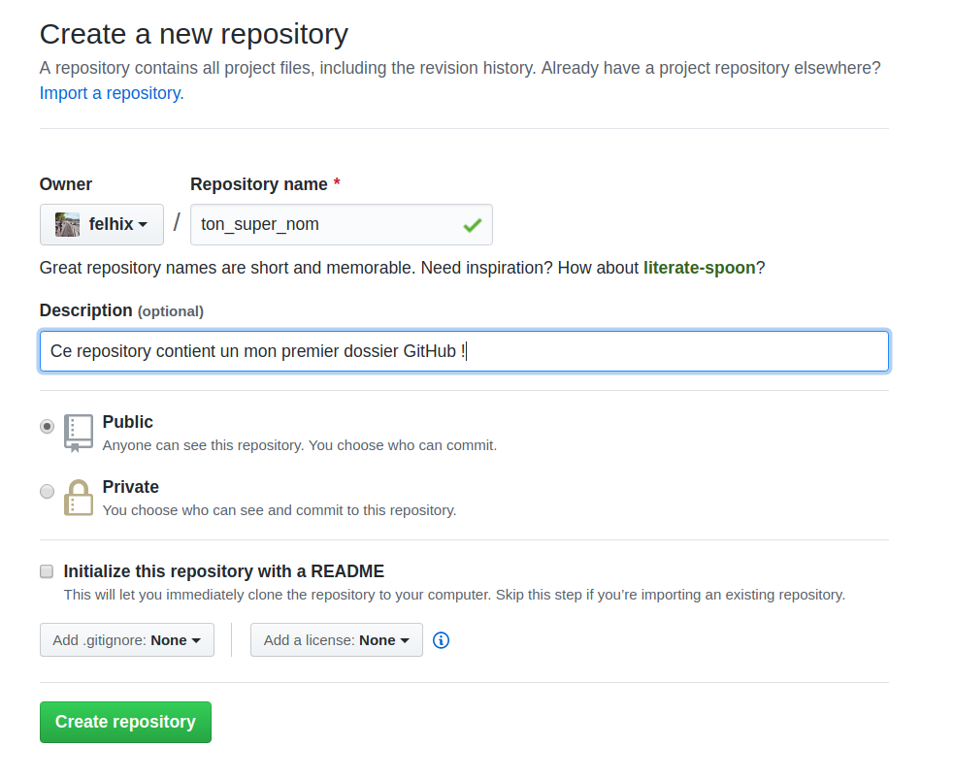
Okay, let's break this down slowly:
- The Repository name is the name of your repository.
- The Description is... its description.
- You can choose to make it public or private
  - Good tip: Most people are a bit suspicious and prefer to put everything in private. On GitHub, you don't really have to worry about public repositories. On the contrary, having nice repositories online shows that you are active on the platform! A bit like a resume, in a way.
- You can initialize it with a README that explains what the project is and how to use it. For this first project, you can do without it.
If you did everything right, you should see this:
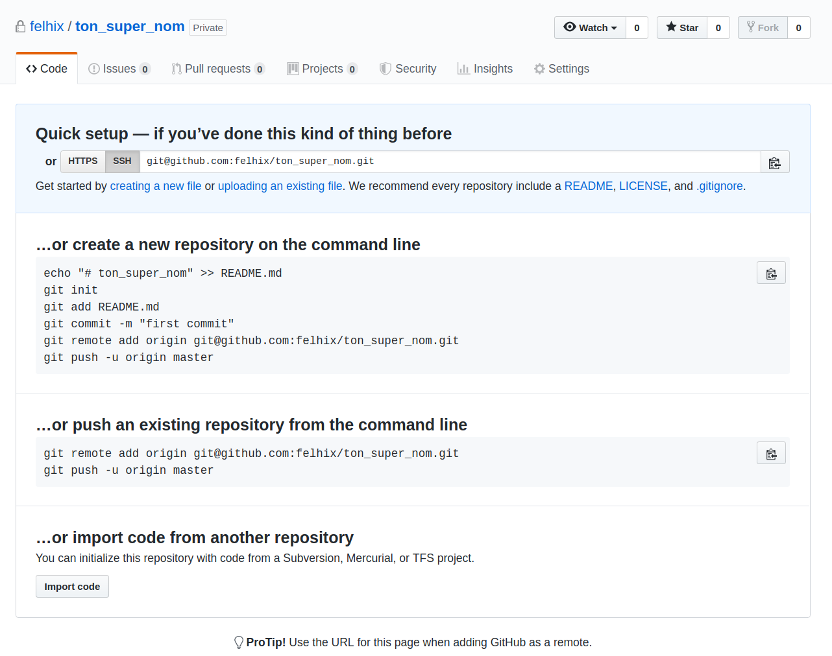
Laisse-moi te traduire ces lignes bizarres en quelque chose de plus compréhensible : en gros, GitHub te dit que ton repository est prêt et qu'il est vide pour le moment. Il te donne même les commandes pour le lier à un repository local, à coup de git remote add origin git@github.com:username/le_nom_de_ton_projet.git. Nous allons voir ensemble la notion de remote dans la prochaine partie.
Let me translate those weird lines into something more understandable: basically, GitHub tells you that your repository is ready and that it is empty for the moment. It even gives you the commands to link it to a local repository, using git remote add origin git@github.com:username/project_name.git. We will see together the notion of remote in the next part.

3.2.2. The concept of remote
What is a "remote repository"? It's a remote version of your Git repo, a bit like a copy stored elsewhere (often on the Internet). You can easily do "local -> remote" or "remote -> local" with Git.
With git remote, you can easily add remotes, see the remotes list, remove remotes.
There are several kinds:
- GitHub, a platform that offers you to have a remote repository, allows you to share your work with others and to have a backup in case of hard time.
- Heroku, which allows you to send him the code of a Rails application so that he can transform it into a server (= publish it on the Internet);
- GitLab, similar to GitHub;
- And many others !
Each remote will have a name. This name can be for example "other_github", "origin", "heroku", or "iloveyou". By convention, the main online repo is called "origin", hence the command $ git remote add origin your_url with which you add a "remote repository" on Github named "origin", with "your_url" as address.
To see all the remote repositories associated with your git folder, you can do: $ git remote -v. This command is very useful because overlaying remotes is a classic mistake when starting out.
Let's continue the example of our restaurant. In your empty repo screen (see previous image), get the command that looks like git remote add origin git@github.com:username/file_name.git. Then, in your terminal, go to the folder of your restaurant and paste the previous command. You should be able to see the remotes by typing git remote --v:
git remote --v
origin git@github.com:felhix/super_folder.git (fetch)
origin git@github.com:felhix/super_folder.git (push)

3.2.3. Git push
The git push command will send your locally stored code to a remote of your choice. It is used by doing: $ git push remote_name branch_name. If you want to push your "master" branch to the "origin" remote, you will do:
$ git push origin master
Or, if you want to push your "other_branch" branch to the "heroku" remote you can do:
$ git push heroku other_branch

🤓 RECURRING QUESTION
But tell me Jamy, what is a branch?
This is not the subject of the course, but I'll make a quick aside about it. A branch, roughly speaking, is a branch of your project that you will work on independently. Thanks to this handy feature, you can work on a parallel version of your project and merge it back together later, when you are happy with the changes you will have made. So far you have only made commits to the Master branch. But you'll see that most features will require you to work on a branch rather than committing directly to Master, to avoid exposing unfinished features to your users.
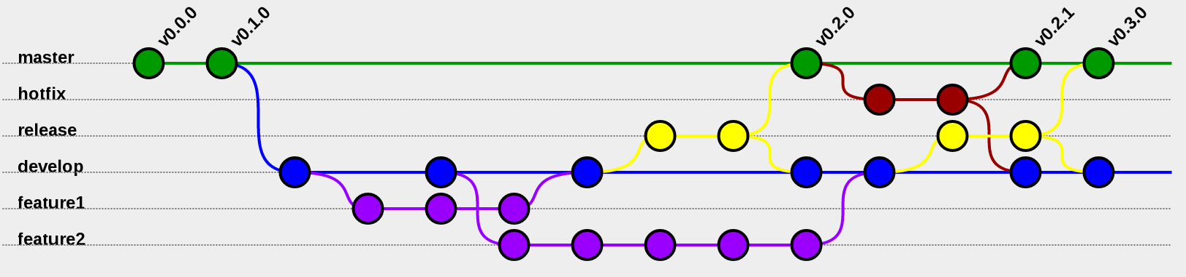

Let's take the example of our website. You would like to redesign the colors of the menu, which represents several days of work. For this, you would create a branch named new_design on which you will make several commits, then show the design to your client. When you are happy, you can merge the new_design branch with the master branch and to you the glory!
For the moment, we are not going to use branches. Just know that this system exists, and that you will work on the main branch named master.

🤓 RECURRING QUESTION
I just initialized a repo but when I push on GitHub, some folders of my repo do not appear (but the rest do). Why is that?
If there are no files in a folder, Git does not push the folder. So don't be surprised if an empty folder on your computer doesn't appear in GitHub: as soon as a file (Ruby or other) is added to it with $ git add then "committed" and pushed, the folder will appear, with the file it contains.

3.2.4. Git pull
The git pull command is the opposite of git push: it replaces the local code with that of the remote of your choice. It is used as follows: $ git pull remote_name branch_name. So, if you want to pull your "master" branch from the "origin" remote you'll do:
$ git pull origin master

3.3. Error messages

Let's not fool ourselves, Git is not easy to use when you are a beginner... Before you rush out and curse your computer, we're going to announce something: it's normal to have errors, especially when you're starting. It has happened to EVERYONE, and especially to those who are comfortable today ❤ The secret is not to lose hope, and to solve your worries slowly, one by one. As every developer has gone through this path, answers to classic problems abound on Stack Overflow. Copy and paste your error message, read the answers, try to understand them, and find the solution to your problem.

🎨 EXAMPLE
Let's take the example of a mistake I had when I started on git. I had a local git repo that I had already linked to a remote origin that was a GitHub repository. I wasn't happy with my GitHub repo, so I deleted it, before re-creating one. Then I wanted to link my local repo to this new GitHub repo using $ git remote add origin url_du_repo. Except that:
<$ git remote add origin url_repo
fatal: remote origin already exists.
Oh my god, Fatal ! Usually, the errors are in "error bug" mode. But here, if it says "fatal", it must be serious, right? No. A quick Google search of the error message, and you'll find out that it's just a remote origin problem that already exists.

In short, I won't hide it from you: you will make mistakes. The key to The Hacking Project's success is your ability to analyze them well, and to make the right Google searches that will solve your problem.

4. To recap

4.0. Récapitulatif vidéo

Is your brain smoking from so much text? Would you like a life-saving video? I've got just what you need. Caroline from the winter 2021 class has put together a video that explains and introduces Git and GitHub. It will help you to get into the Git world :) THP is a supportive community where students can come and contribute to the common good. Even you can contribute to THP, don't forget that ❤️

4.1. Practical commands
Here is a summary of the basic commands:
- $ git init: ALWAYS start by initializing git with this command. It is this command that turns your current directory into a git repository.
- $ git add your_file: adds the mentioned file to the backups.
- $ git commit -m "your comment": creates a commit (commit = save followed by a comment).
- $ git status: gives you the current status of git.

4.2. Read the history
$ git log: allows to see the history of all the commits, which are sorted by:
- SHA : list of numbers and letters that uniquely identify the commit.
- Author
- Date
- Message provided at the time of the commit, which must be clear and precise to allow you to know what you were doing at the time of this backup. It may be a pain, but you'll thank yourself later.
To exit the log, press Q.

4.3. Position yourself on a given commit
Let's say we want to check something out on an old commit. We'll use the $ git checkout command, like this:
- $ git checkout 45581cebdd2cae494f80f44010af9e4a86c9b8fa: tells git to position itself on this particular SHA. Be careful not to make any changes!
- $ git checkout master: once we are done browsing, we must return to the current version of our repository with this command.
If you want to roll back permanently, you'll use $ git reset --hard SHA.
- $ git reset --hard 45581cebdd2cae494f80f44010af9e4a86c9b8fa: we tell git to position itself on this specific SHA.
- $ git reset --hard: erases everything to return to the last commit.

5. To go further

The OpenClassrooms course on Git is a very good resource to go further, including the notion of branches and merges.

Here is also a course on Git from the Viking Code School. It explains well the basics of Git and provides a good alternative to ours.

